Create two instances one is master and another one is slave and connect the two instances to terminal.

* Install java and Jenkins in master
* Install java in slave
* Make some configurations by using SSH-AGENT
* By using SSH-AGENT, connect the master and slave without any public key’s

1. Install Apache-Tomcat in Slave node and unzip all the files.

* wget <https://downloads.apache.org/tomcat/tomcat-9/v9.0.76/bin/apache-tomcat-9.0.76.tar.gz.asc>
* tar -xvf apache-tomcat-9.0.76.tar.gz

1. Now do some configurations in Apache-tomcat.

* cd apache-tomcat-9.0.76.tar.gz
* cd conf
* sudo vi tomcat-users.xml
* paste this in tomcat-users.xml
* <user username="tomcat" password="admin" roles="manager-gui,admin-gui,manager-script"/>

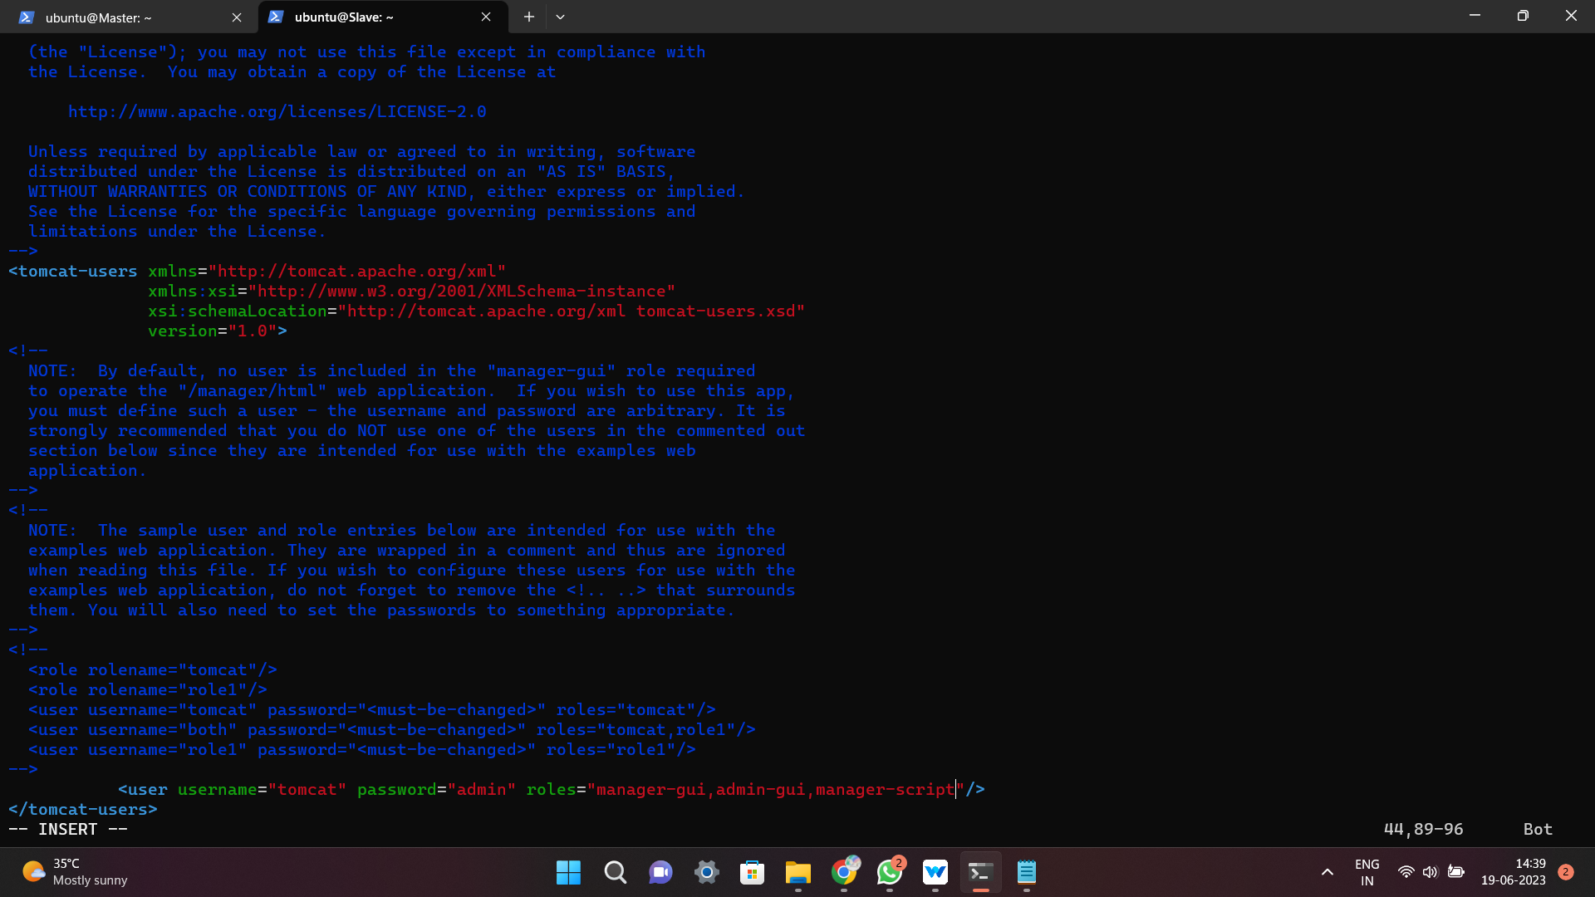

1. After installing tomcat now do some configuration in **Host-manager** file and **Manager file**.

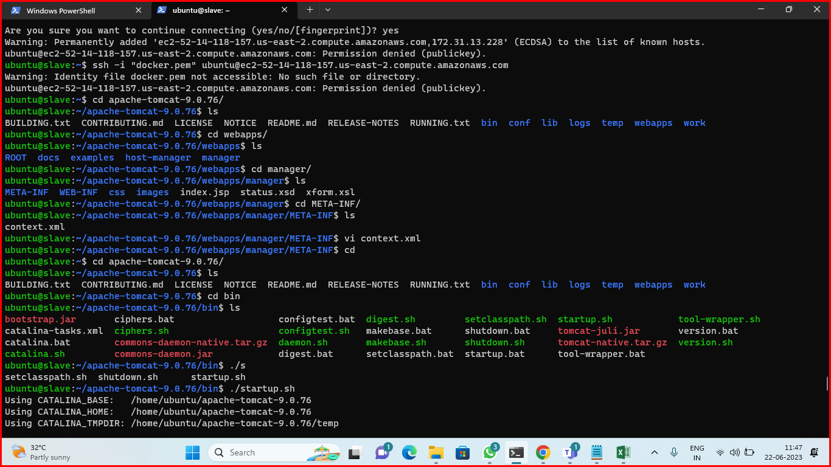

1. Now modify the Manager file.

* go to webapps
* cd webapps
* cd manager
* cd META-INF
* sudo vi context.xml
* paste this in context.xml
* <!--Valve className="org.apache.catalina.valves.RemoteAddrValve"
  + allow="127\.\d+\.\d+\.\d+|::1|0:0:0:0:0:0:0:1" /-->

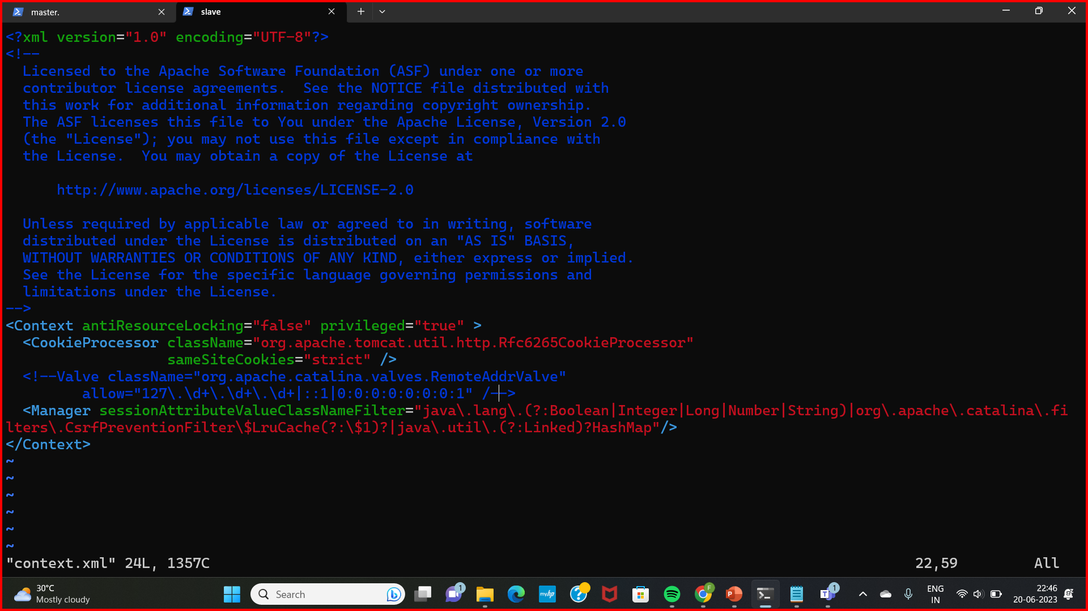

1. Now modify the Host-manager file.

* cd host-manager
* cd META-INF
* sudo vi context.xml
* paste this in context.xml
* <!--Valve className="org.apache.catalina.valves.RemoteAddrValve"
* allow="127\.\d+\.\d+\.\d+|::1|0:0:0:0:0:0:0:1" /-->



1. Configurations all done. Now start the Apache-tomcat server.

* cd apache-tomcat-9.0.76
* cd bin
* ./startup.sh



1. Browse the Ip address.

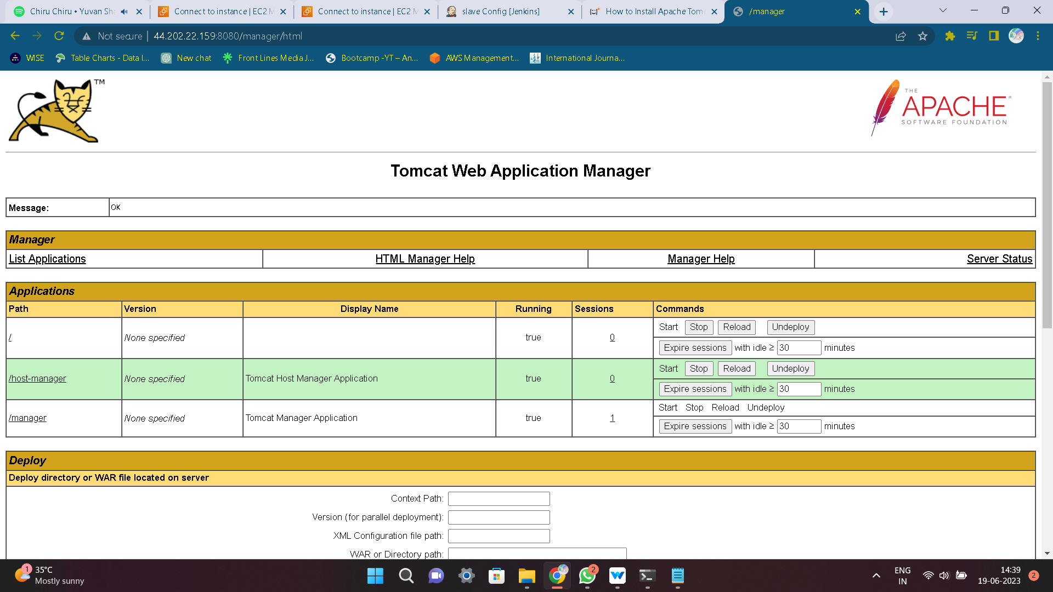

1. 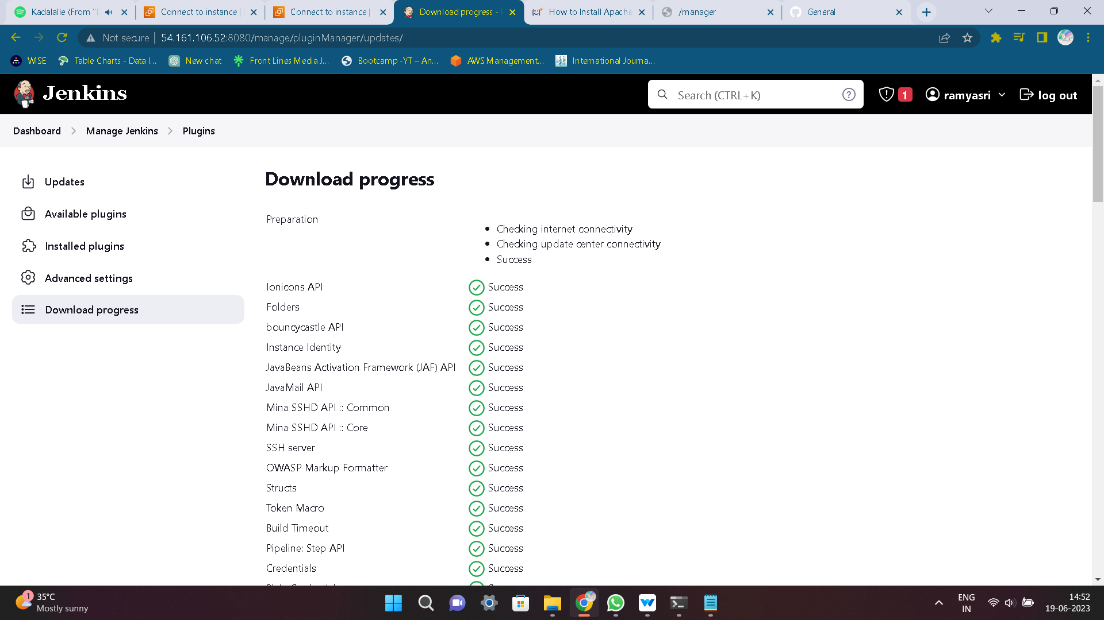Now setup Jenkins in master node and install some required plugins.
2. Suggested Plugins are installed. So now create a pipeline and add the script.
3. Before creating pipeline install Maven build tool for testing and building.
4. Enter the pipeline script.

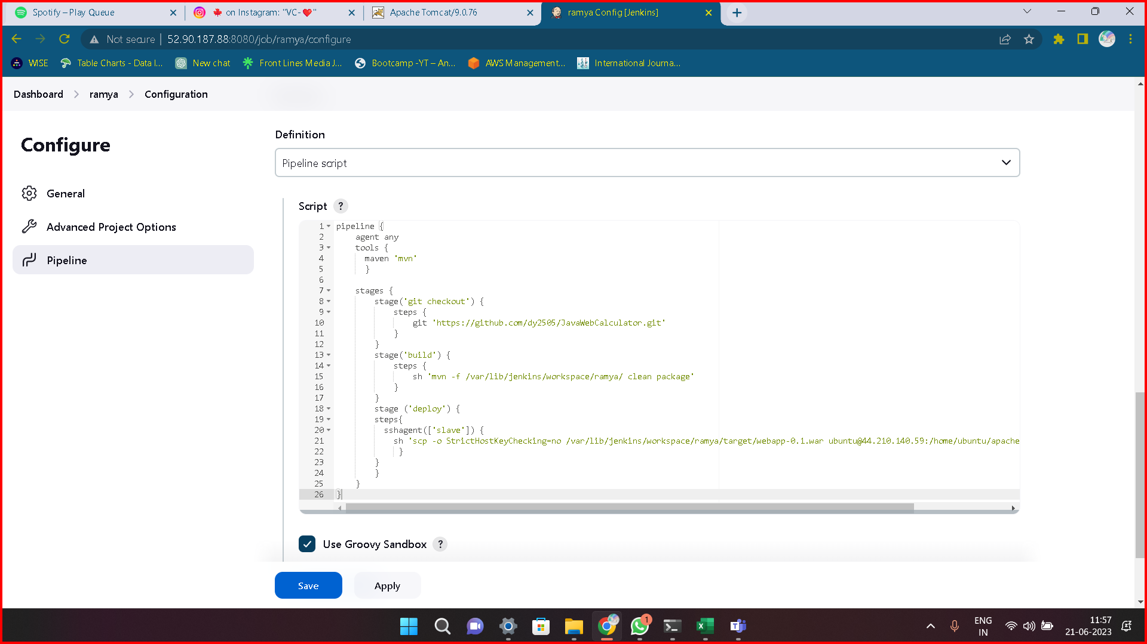

1. Successfully the pipeline is Done!
2. Now Browse the Ip address we get the output of WEB calculator.